**Name**: Prajakta Keer

**Class**: TE 10

**Roll No**: 33231

**Problem Statement:**- NUTRI JUNCTION : A website which gives information about nutritional aspects of human life.

# Home Page:

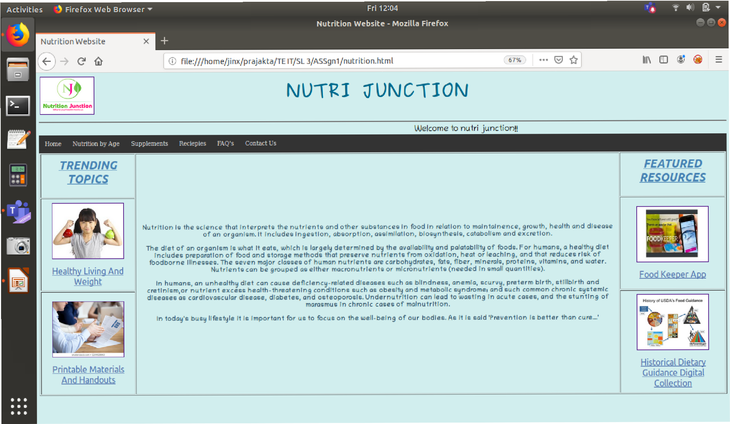

**Nutrition by Age:**

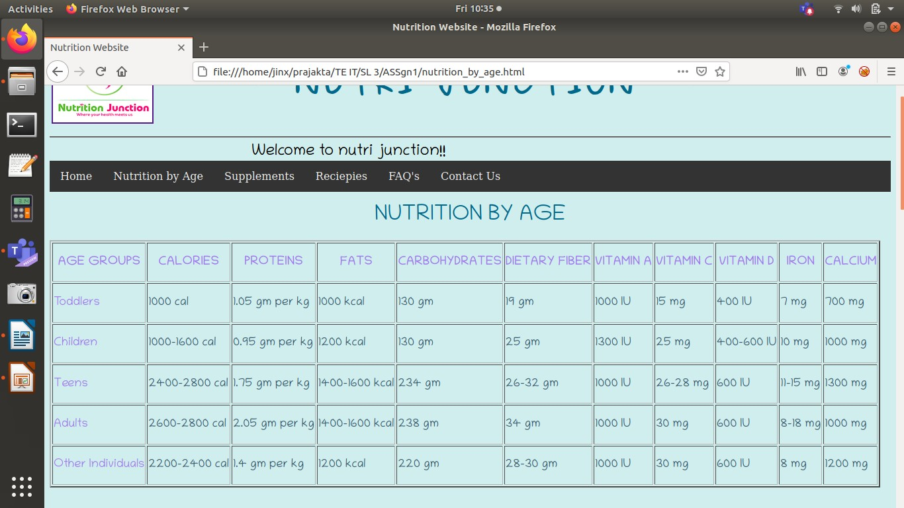

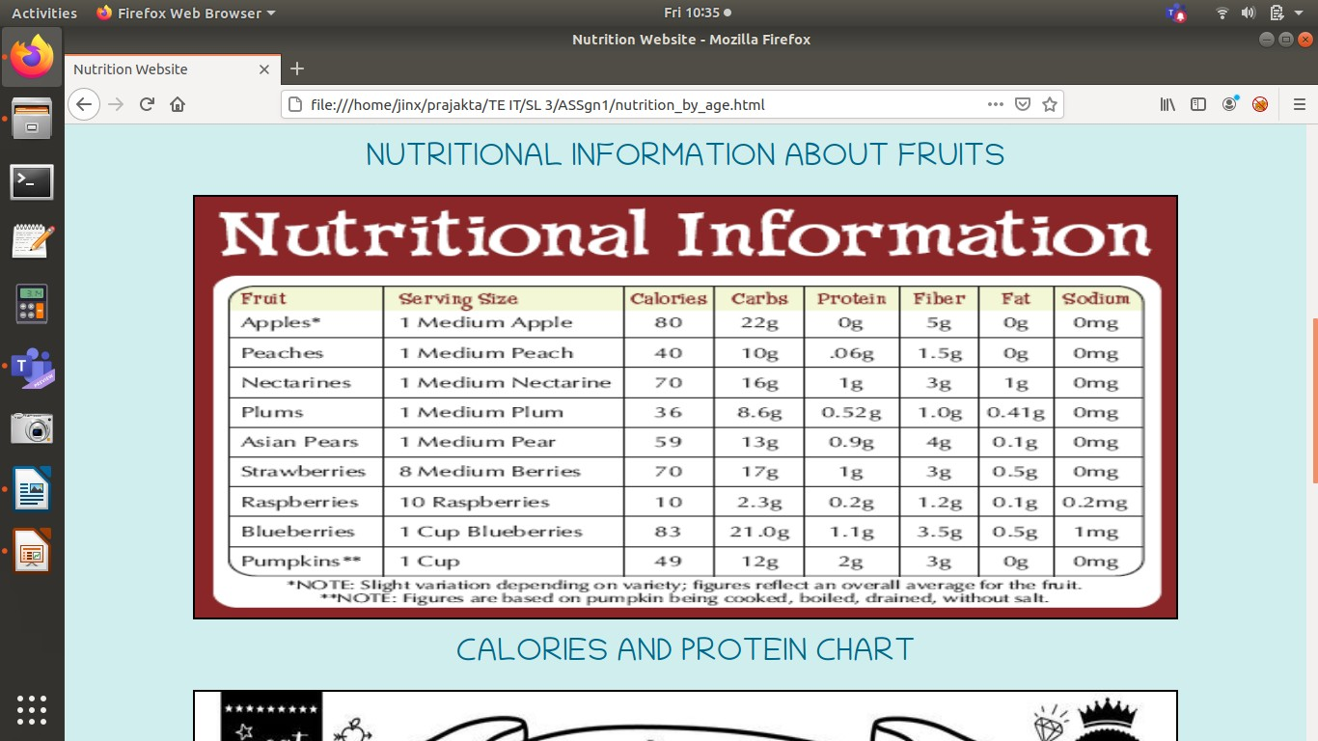

+-›c'&

  

CALORIESANDPROTEINCHART

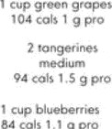





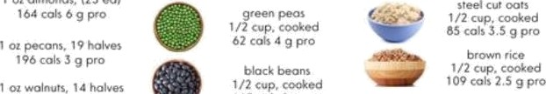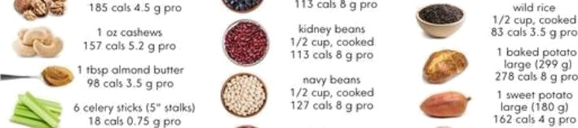

# SUPPLEMENTS:

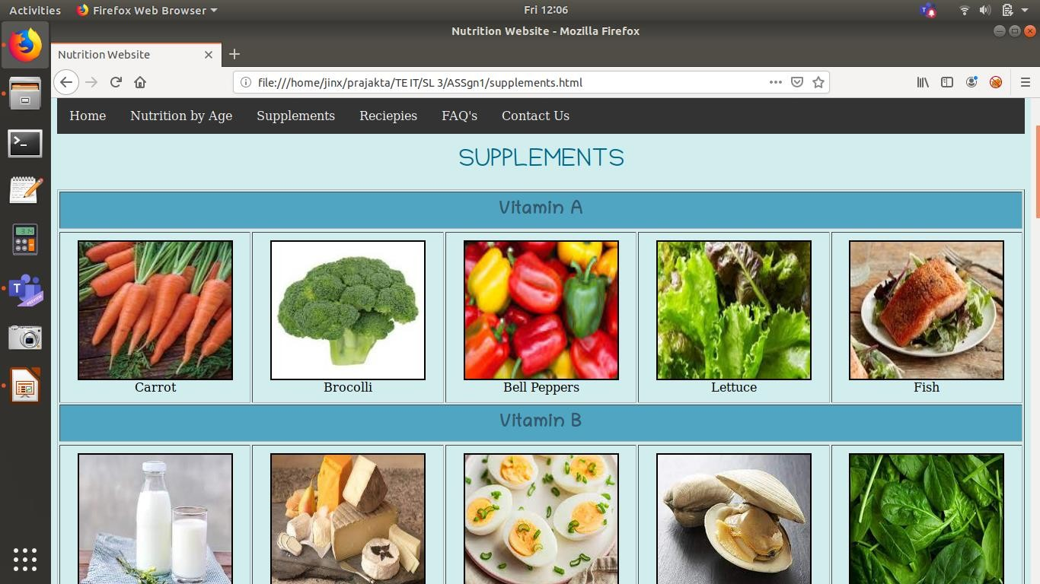

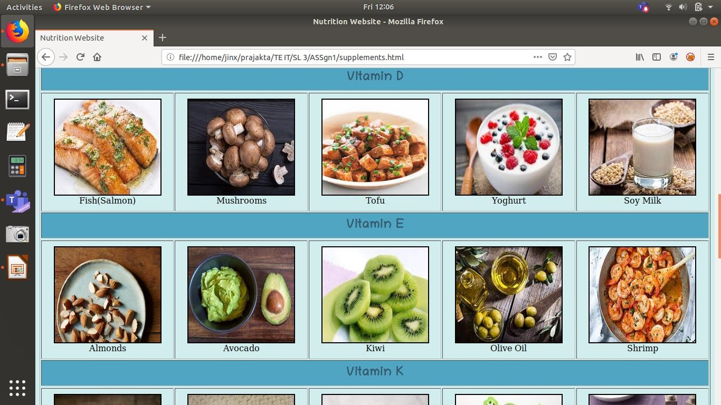

**RECIEPIES:**

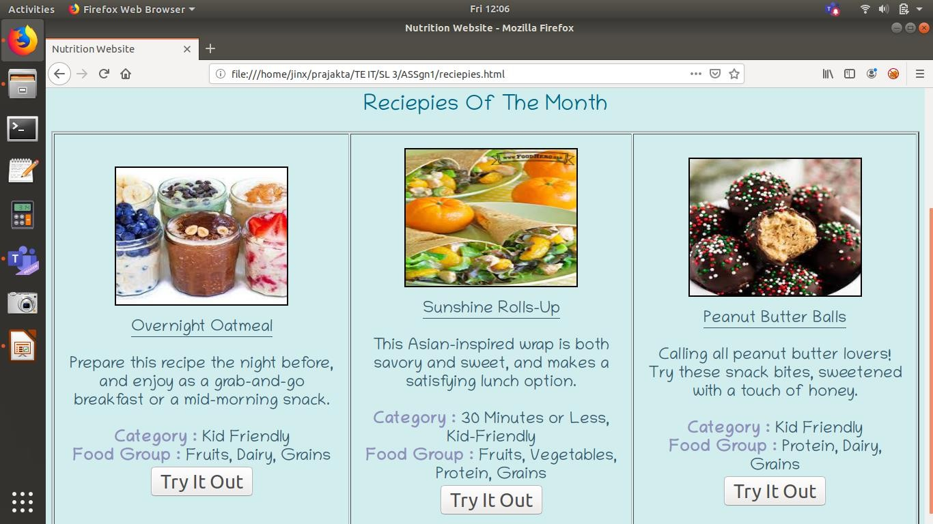

**FAQ’s:**

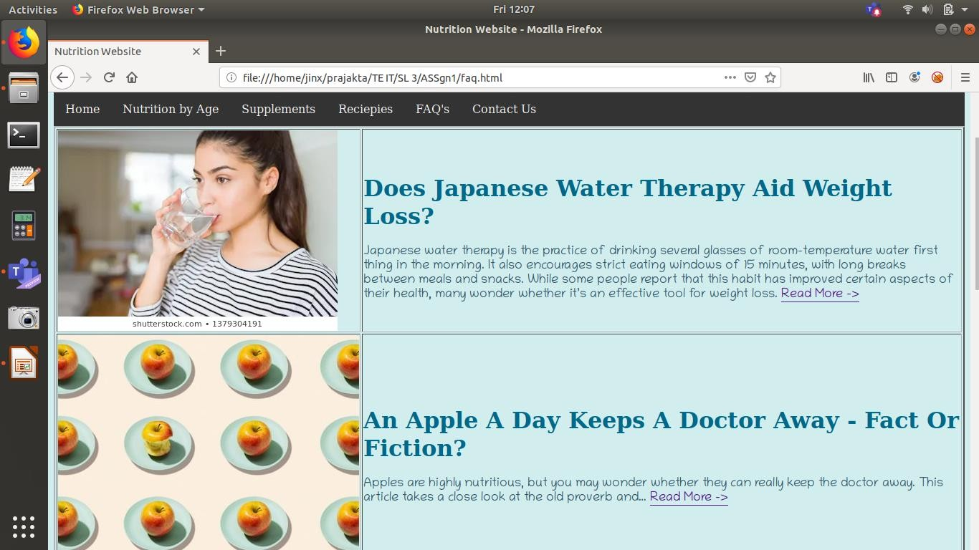

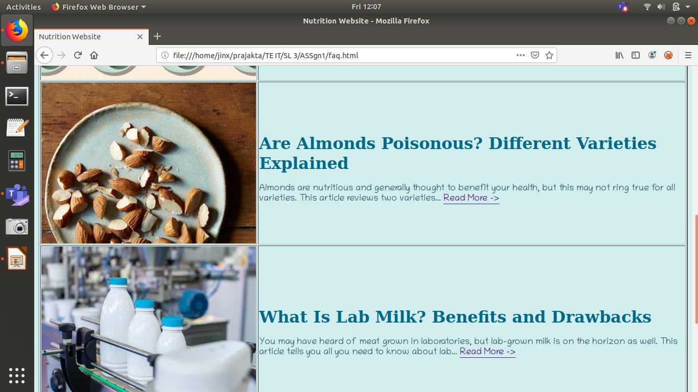

**CONTACT US:**

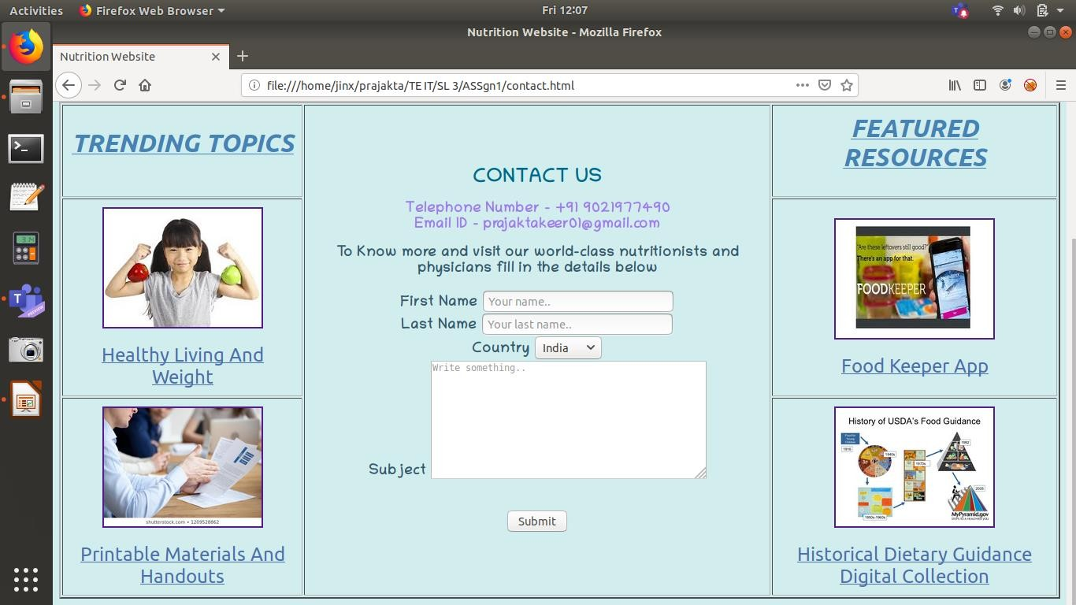

**FEATURED RESOURCES-FOOD KEEPER APP**

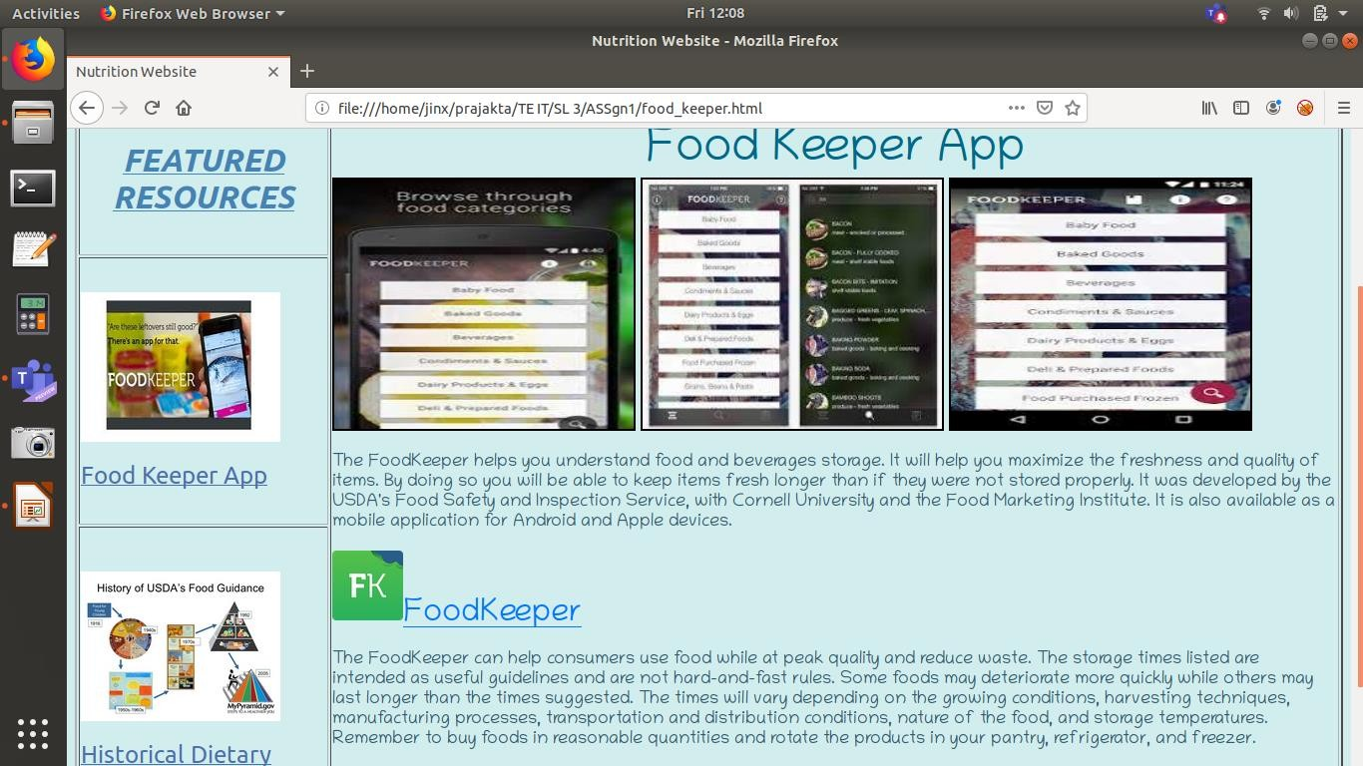

**FEATUREDRESOURCES-HISTORICALDIETARYGUIDANCE ANDDIGITALCOLLECTION**

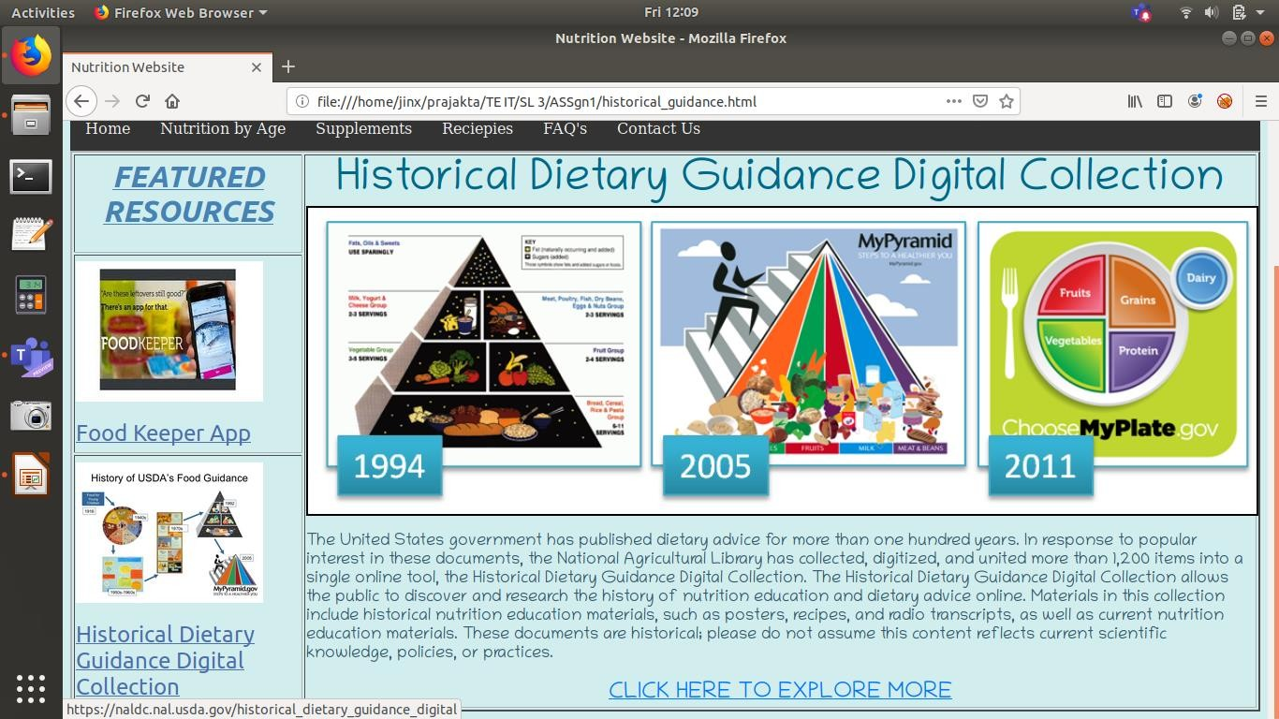

**TRENDING TOPICS-HEALTHY LIVING AND WEIGHT**

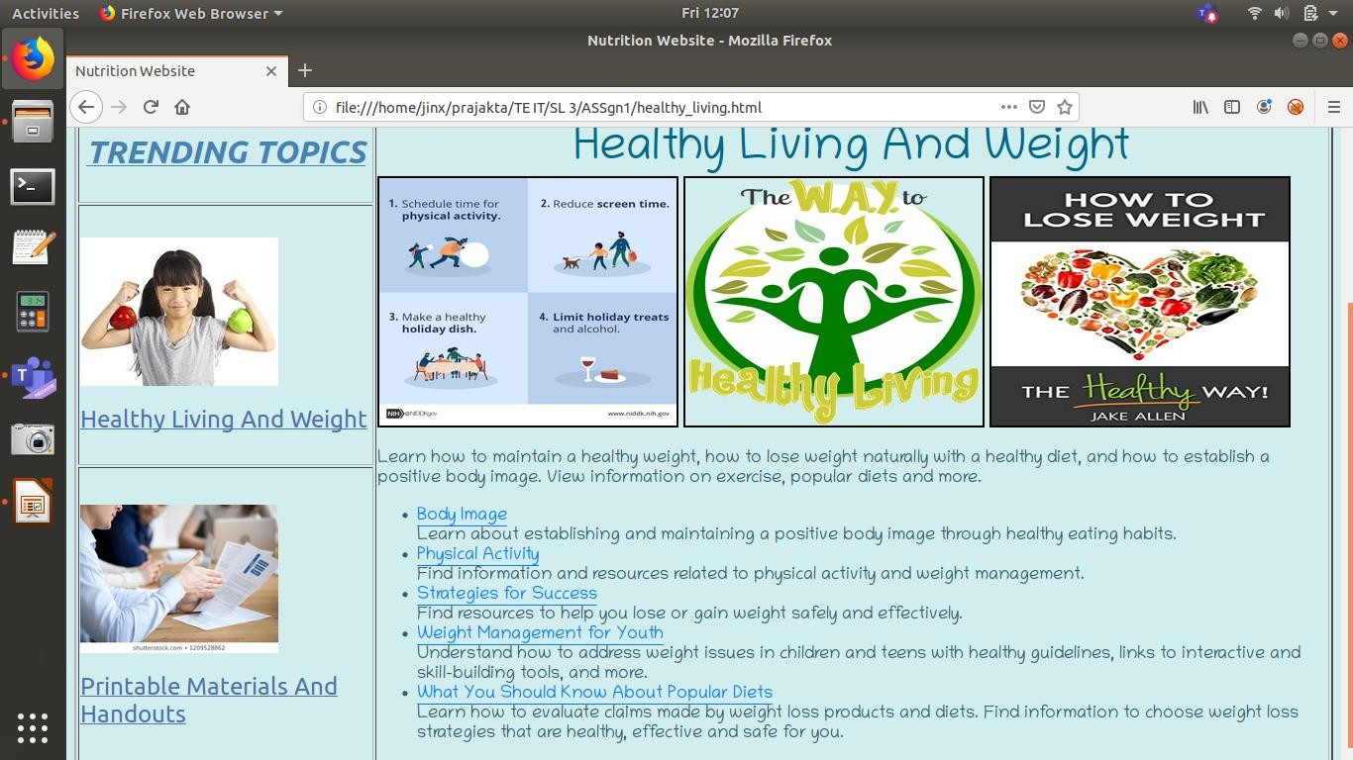

**TRENDING TOPICS –PRINTABLE MATERIALSANDHANDOUTS**

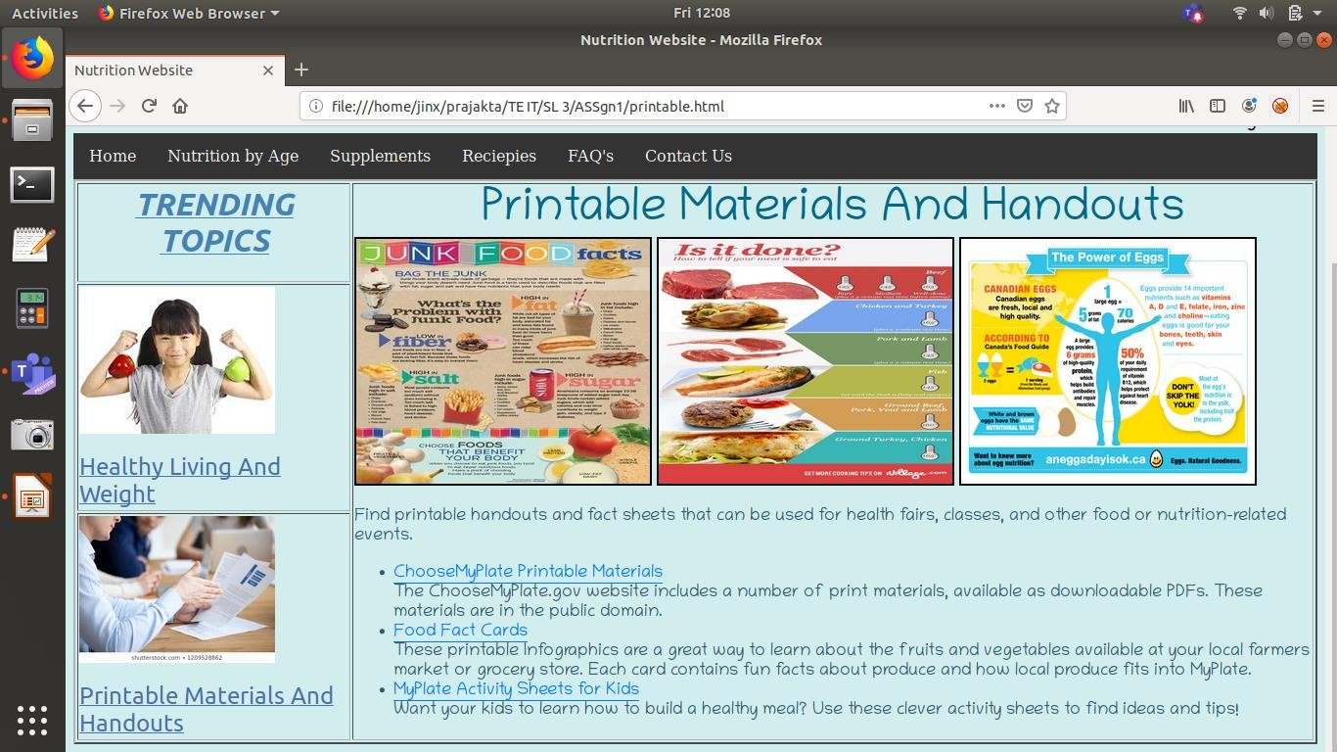

**SOURCE CODE FOR HOME PAGE**

<html>

<head>

<link rel = "stylesheet" href="nutrition.css">

<title>Nutrition Website</title>

</head>

<body bgcolor = "#D1EEEE">

<p>

<table width = "80%">

<tr>

<td><a href="nutrition.html"><img src = "logo.png" height = "100" width = "150" border = "2"></a></td>

<td style="text-align:center"><font color = "#00688B" size = "10" face = "Purisa"><b>NUTRI JUNCTION</font></p></font>

</tr>

</table>

<hr>

<font size = "5" face = "Chilanka"><marquee>Welcome to nutri junction!!</marquee></font>

<div class="navbar">

<a href="nutrition.html">Home</a>

<a href="nutrition_by_age.html">Nutrition by Age</a>

<a href="supplements.html">Supplements</a>

<a href="reciepies.html">Reciepies</a>

<a href="faq.html">FAQ's</a>

<a href="contact.html">Contact Us</a>

</div>

<table border = "2" cellpadding = "10">

<tr>

<th><h1><i><u><font color = "#4682B4" face = "Ubuntu">TRENDING

TOPICS</h1></font></i></u></th>

<th rowspan = 3><p><font color = "#35586C" face = "Chilanka" size = "4">Nutrition is the science that interprets the nutrients and other substances in food in relation to maintainence, growth, health and disease of an organism. It includes ingestion, absorption, assimilation, biosynthesis, catabolism and excretion.</p>

<p>The diet of an organism is what it eats, which is largely determined by the availability and palatability of foods. For humans, a healthy diet includes preparation of food and storage methods that preserve nutrients from oxidation, heat or leaching, and that reduces risk of foodborne illnesses. The seven major classes of human nutrients are carbohydrates, fats, fiber, minerals,

proteins, vitamins, and water. Nutrients can be grouped as either macronutrients or micronutrients (needed in small quantities).</p>

<p>In humans, an unhealthy diet can cause deficiency-related diseases such as blindness, anemia, scurvy, preterm birth, stillbirth and cretinism,or nutrient excess health-threatening conditions such as obesity and metabolic syndrome; and such common chronic systemic diseases as cardiovascular disease, diabetes, and osteoporosis. Undernutrition can lead to wasting in acute cases, and the stunting of marasmus in chronic cases of malnutrition.</p>

<p>In today's busy lifestyle it is important for us to focus on the well-being of our bodies. As it is said 'Prevention is better than cure...'

</font> </th>

<th><h1><i><u><font color = "#4682B4" face = "Ubuntu">FEATURED RESOURCES</h1></font></i></u></th>

</tr>

<tr>

<td style="text-align:center"><a href="healthy_living.html"><img src = "healthy_living.jpeg"

height = "150" width = "200" border = "2"><br><br><font color = "#4D6FAC" size = "5" face = "Ubuntu">Healthy Living And Weight</font></a></img>

<td style="text-align:center"><ahref="food_keeper.html"><imgsrc ="foodkeeper.jpeg"height = "150" width = "200" border = "2"><br><br><font color ="#4D6FAC"size = "5" face = "Ubuntu">Food Keeper App</a></li></font></img>

</tr>

<tr>

<td style="text-align:center"><a href="printable.html"><img src = "printables.jpg" height =

"150" width = "200" border = "2"><br><br><font color = "#4D6FAC" size = "5" face = "Ubuntu">Printable Materials And Handouts</a></img>

<td style="text-align:center"><a href="historical_guidance.html"><img src = "hist_guidance.jpg" height = "150" width = "200" border = "2"><br><br><font color = "#4D6FAC" size = "5" face = "Ubuntu">Historical Dietary Guidance Digital Collection</a></li></font></img>

</tr>

</table>

</body>

</html>

<html>

# SOURCE CODE FOR NUTRITION BY AGE PAGE

<head>

<link rel = "stylesheet" href="nutrition.css">

<title>Nutrition Website</title>

</head>

<body bgcolor = "#D1EEEE">

<p>

<table width = "80%">

<tr>

<td><a href="nutrition.html"><img src = "logo.png" height = "100" width = "150" border = "2"></a></td>

<td style="text-align:center"><font color = "#00688B" size = "10" face = "Purisa"><b>NUTRI JUNCTION</font></p></font>

</tr>

</table>

<hr>

<font size = "5" face = "Chilanka"><marquee>Welcome to nutri junction!!</marquee></font>

<div class="navbar">

<a href="nutrition.html">Home</a>

<a href="nutrition_by_age.html">Nutrition by Age</a>

<a href="supplements.html">Supplements</a>

<a href="reciepies.html">Reciepies</a>

<a href="faq.html">FAQ's</a>

<a href="contact.html">Contact Us</a>

</div>

<br>

<center><font size = "6" color = "#00688B" face = "Chilanka">NUTRITION BY AGE</font></center><br>

<table border = "2" height = "60%">

<tr>

<th><font size = "4" color = "#9F79EE" face = "Chilanka">AGE GROUPS</th></font>

<th><fontsize="4"color="#9F79EE"face="Chilanka">CALORIES

<th><fontsize="4"color="#9F79EE"face="Chilanka">PROTEINS

<tH><font size = "4" color = "#9F79EE" face = "Chilanka">FATS

<th><font size = "4" color = "#9F79EE" face = "Chilanka">CARBOHYDRATES

<th><font size = "4" color = "#9F79EE" face = "Chilanka">DIETARY FIBER

<th><fontsize="4"color="#9F79EE"face="Chilanka">VITAMINA

<th><fontsize="4"color="#9F79EE"face="Chilanka">VITAMINC

<th><fontsize="4"color="#9F79EE"face="Chilanka">VITAMIND

<th><font size = "4" color = "#9F79EE" face = "Chilanka">IRON

<th><font size = "4" color = "#9F79EE" face = "Chilanka">CALCIUM

</tr></font>

<tr>

</tr>

<tr>

</tr>

<tr>

</tr>

<tr>

<td><font size = "4" color = "#9F79EE" face = "Chilanka">Toddlers</td>

<td><font size = "4" color = "#35586C" face = "Chilanka">1000 cal

<td><font size = "4" color = "#35586C" face = "Chilanka">1.05 gm per kg

<td><font size = "4" color = "#35586C" face = "Chilanka">1000 kcal

<td><font size = "4" color = "#35586C" face = "Chilanka">130 gm

<td><font size = "4" color = "#35586C" face = "Chilanka">19 gm

<td><font size = "4" color = "#35586C" face = "Chilanka">1000 IU

<td><fontsize= "4" color = "#35586C" face = "Chilanka">15mg

<td><fontsize= "4" color = "#35586C" face = "Chilanka">400IU

<td><font size = "4" color = "#35586C" face = "Chilanka">7 mg

<td><font size = "4" color = "#35586C" face = "Chilanka">700 mg

<td><font size = "4" color = "#9F79EE" face = "Chilanka">Children</td>

<td><font size = "4" color = "#35586C" face = "Chilanka">1000-1600 cal

<td><font size = "4" color = "#35586C" face = "Chilanka">0.95 gm per kg

<td><font size = "4" color = "#35586C" face = "Chilanka">1200 kcal

<td><font size = "4" color = "#35586C" face = "Chilanka">130 gm

<td><font size = "4" color = "#35586C" face = "Chilanka">25 gm

<td><font size = "4" color = "#35586C" face = "Chilanka">1300 IU

<td><font size = "4" color = "#35586C" face = "Chilanka">25 mg

<td><font size = "4" color = "#35586C" face = "Chilanka">400-600 IU

<td><font size = "4" color = "#35586C" face = "Chilanka">10 mg

<td><font size = "4" color = "#35586C" face = "Chilanka">1000 mg

<td><font size = "4" color = "#9F79EE" face = "Chilanka">Teens</td>

<td><font size = "4" color = "#35586C" face = "Chilanka">2400-2800 cal

<td><fontsize= "4" color = "#35586C" face = "Chilanka">1.75 gm perkg

<td><fontsize= "4" color = "#35586C" face = "Chilanka">1400-1600kcal

<td><font size = "4" color = "#35586C" face = "Chilanka">234 gm

<td><font size = "4" color = "#35586C" face = "Chilanka">26-32 gm

<td><font size = "4" color = "#35586C" face = "Chilanka">1000 IU

<td><font size = "4" color = "#35586C" face = "Chilanka">26-28 mg

<td><font size = "4" color = "#35586C" face = "Chilanka">600 IU

<td><font size = "4" color = "#35586C" face = "Chilanka">11-15 mg

<td><font size = "4" color = "#35586C" face = "Chilanka">1300 mg

<td><font size = "4" color = "#9F79EE" face = "Chilanka">Adults</td>

<td><font size = "4" color = "#35586C" face = "Chilanka">2600-2800 cal

<td><fontsize= "4" color = "#35586C" face = "Chilanka">2.05 gm perkg

<td><fontsize= "4" color = "#35586C" face = "Chilanka">1400-1600kcal

</tr>

<tr>

</tr>

<td><font size = "4" color = "#35586C" face = "Chilanka">238 gm

<td><font size = "4" color = "#35586C" face = "Chilanka">34 gm

<td><font size = "4" color = "#35586C" face = "Chilanka">1000 IU

<td><fontsize= "4" color = "#35586C" face = "Chilanka">30mg

<td><fontsize= "4" color = "#35586C" face = "Chilanka">600IU

<td><font size = "4" color = "#35586C" face = "Chilanka">8-18 mg

<td><font size = "4" color = "#35586C" face = "Chilanka">1000 mg

<td><font size = "4" color = "#9F79EE" face = "Chilanka">Other Individuals</td>

<td><font size = "4" color = "#35586C" face = "Chilanka">2200-2400 cal

<td><font size = "4" color = "#35586C" face = "Chilanka">1.4 gm per kg

<td><font size = "4" color = "#35586C" face = "Chilanka">1200 kcal

<td><font size = "4" color = "#35586C" face = "Chilanka">220 gm

<td><font size = "4" color = "#35586C" face = "Chilanka">28-30 gm

<td><font size = "4" color = "#35586C" face = "Chilanka">1000 IU

<td><fontsize= "4" color = "#35586C" face = "Chilanka">30mg

<td><fontsize= "4" color = "#35586C" face = "Chilanka">600IU

<td><font size = "4" color = "#35586C" face = "Chilanka">8 mg

<td><font size = "4" color = "#35586C" face = "Chilanka">1200 mg

</table></font><br><br>

<center><font size = "6" color = "#00688B" face = "Chilanka">NUTRITIONAL INFORMATION ABOUT FRUITS</font></center><br>

<center><img src = "friut.gif" height = "70%" width = "80%" border = "2"></img><br><br>

<center><font size = "6" color = "#00688B" face = "Chilanka">CALORIES AND PROTEIN CHART</font></center><br>

<center><img src = "cal_pro_chart.jpg" width = "80%" border = "2"></img>

</body>

</html>

<html>

# SOURCE CODE FOR SUPPLEMENTS PAGE

<head>

<link rel = "stylesheet" href="nutrition.css">

<title>Nutrition Website</title>

</head>

<body bgcolor = "#D1EEEE">

<p>

<table width = "80%">

<tr>

<td><a href="nutrition.html"><img src = "logo.png" height = "100" width = "150" border = "2"></a></td>

<td style="text-align:center"><font color = "#00688B" size = "10" face = "Purisa"><b>NUTRI JUNCTION</font></p></font>

</tr>

</table>

<hr>

<font size = "5" face = "Chilanka"><marquee>Welcome to nutri junction!!</marquee></font>

<div class="navbar">

<a href="nutrition.html">Home</a>

<a href="nutrition_by_age.html">Nutrition by Age</a>

<a href="supplements.html">Supplements</a>

<a href="reciepies.html">Reciepies</a>

<a href="faq.html">FAQ's</a>

<a href="contact.html">Contact Us</a>

</div><br>

<center><font size = "6" color = "#00688B" face = "Chilanka">SUPPLEMENTS</font></center><br>

<table border = "1" width = "100%" cellpadding = "10">

<tr>

<th colspan = "5" style = "background-color: #50A6C2;"><font color = "#35586C" face =

"Chilanka" size = "5">Vitamin A</font>

<tr>

<tr>

<td style="text-align:center"><img src = "carrot.jpeg" height = "180" width = "200" border =

"2"><br>Carrot<br>

<td style="text-align:center"><img src = "brocolli.jpeg" height = "180" width = "200" border

= "2"><br>Brocolli<br>

<td style="text-align:center"><img src = "bell_pepper.jpeg" height = "180" width = "200" border = "2"><br>Bell Peppers<br>

<td style="text-align:center"><img src = "lettuce.jpeg" height = "180" width = "200" border

= "2"><br>Lettuce<br>

<td style="text-align:center"><img src = "fish.jpeg" height = "180" width = "200" border = "2"><br>Fish<br>

</tr>

<tr>

<th colspan = "5" style = "background-color: #50A6C2;"><font color = "#35586C" face =

"Chilanka" size = "5">Vitamin B</font>

<tr>

<tr>

<td style="text-align:center"><img src = "milk.jpeg" height = "180" width = "200" border =

"2"><br>Milk

<td style="text-align:center"><img src = "cheese.jpeg" height = "180" width = "200" border

= "2"><br>Cheese

<td style="text-align:center"><img src = "eggs.jpeg" height = "180" width = "200" border = "2"><br>Eggs

<td style="text-align:center"><img src = "shellfish.jpeg" height = "180" width = "200" border = "2"><br>Shellfish

<td style="text-align:center"><img src = "spianch.jpeg" height = "180" width = "200" border

= "2"><br>Spinach

</tr>

<tr>

<th colspan = "5" style = "background-color: #50A6C2;"><font color = "#35586C" face =

"Chilanka" size = "5">Vitamin C</font>

<tr>

<tr>

<td style="text-align:center"><img src = "tomatoes.jpeg" height = "180" width = "200"

border = "2"><br>Tomatoes

<td style="text-align:center"><img src = "lemon.jpeg" height = "180" width = "200" border

= "2"><br>Lemon

<td style="text-align:center"><img src = "strawberry.jpeg" height = "180" width = "200" border = "2"><br>Strawberries

<td style="text-align:center"><img src = "orange.jpeg" height = "180" width = "200" border

= "2"><br>Orange

<td style="text-align:center"><img src = "guava.jpeg" height = "180" width = "200" border = "2"><br>Guava

</tr>

<tr>

<th colspan = "5" style = "background-color: #50A6C2;"><font color = "#35586C" face =

"Chilanka" size = "5">Vitamin D</font>

<tr>

<tr>

<td style="text-align:center"><img src = "salmon.jpeg" height = "180" width = "200" border

= "2"><br>Fish(Salmon)

<td style="text-align:center"><img src = "mushroom.jpeg" height = "180" width = "200" border = "2"><br>Mushrooms

<td style="text-align:center"><img src = "tofu.jpeg" height = "180" width = "200" border = "2"><br>Tofu

<td style="text-align:center"><img src = "yoghurt.jpeg" height = "180" width = "200" border

= "2"><br>Yoghurt

<td style="text-align:center"><img src = "soy_milk.jpeg" height = "180" width = "200" border = "2"><br>Soy Milk

</tr>

<tr>

<th colspan = "5" style = "background-color: #50A6C2;"><font color = "#35586C" face =

"Chilanka" size = "5">Vitamin E</font>

<tr>

<tr>

<td style="text-align:center"><img src = "almonds.jpg" height = "180" width = "200" border

= "2"><br>Almonds

<td style="text-align:center"><img src = "avocado.jpeg" height = "180" width = "200" border = "2"><br>Avocado

<td style="text-align:center"><img src = "kiwi.jpeg" height = "180" width = "200" border = "2"><br>Kiwi

<td style="text-align:center"><img src = "olive_oil.jpeg" height = "180" width = "200" border = "2"><br>Olive Oil

<td style="text-align:center"><img src = "shrimp.jpeg" height = "180" width = "200" border

= "2"><br>Shrimp

</tr>

<tr>

<th colspan = "5" style = "background-color: #50A6C2;"><font color = "#35586C" face =

"Chilanka" size = "5">Vitamin K</font>

<tr>

<tr>

<td style="text-align:center"><img src = "cabbage.jpeg" height = "180" width = "200"

border = "2"><br>Cabbage

<td style="text-align:center"><img src ="cucumber.jpeg"height = "180" width = "200" border ="2"><br>Cucumber

<tdstyle="text-align:center"><imgsrc="asparagus.jpeg"height="180"width="200" border ="2"><br>Asparagus

<td style="text-align:center"><img src = "okra.jpeg" height = "180" width = "200" border = "2"><br>Okra

<td style="text-align:center"><img src = "green_beans.jpeg" height = "180" width = "200" border = "2"><br>Green Beans

</tr>

<tr>

<th colspan = "5" style = "background-color: #50A6C2;"><font color = "#35586C" face = "Chilanka" size = "5">Calcium</font>

<tr>

<tr>

<td style="text-align:center"><img src = "paneer.jpeg" height = "180" width = "200" border

= "2"><br>Paneer

<td style="text-align:center"><img src = "grated_parmesan.jpeg" height = "180" width = "200" border = "2"><br>Grated Parmesan

<td style="text-align:center"><img src = "cowpeas.jpeg" height = "180" width = "200" border = "2"><br>Cowpeas

<td style="text-align:center"><img src = "trout.jpeg" height = "180" width = "200" border = "2"><br>Trout

<td style="text-align:center"><img src = "clams.jpeg" height = "180" width = "200" border = "2"><br>Clams

</tr>

<tr>

<th colspan = "5" style = "background-color: #50A6C2;"><font color = "#35586C" face =

"Chilanka" size = "5">Sodium</font>

<tr>

<tr>

<td style="text-align:center"><img src = "cereals.jpeg" height = "180" width = "200" border

= "2"><br>Cereals

<td style="text-align:center"><img src = "oysters.jpeg" height = "180" width = "200" border

= "2"><br>Oysters

<td style="text-align:center"><img src = "apricot.jpeg" height = "180" width = "200" border

= "2"><br>Apricots

<td style="text-align:center"><img src = "quinoa.jpeg" height = "180" width = "200" border

= "2"><br>Quinoa

<td style="text-align:center"><img src = "pumpkin_seeds.jpeg" height = "180" width = "200" border = "2"><br>Pumpkin Seeds

</tr>

<tr>

<th colspan = "5" style = "background-color: #50A6C2;"><font color = "#35586C" face =

"Chilanka" size = "5">Iron</font>

<tr>

<tr>

<td style="text-align:center"><img src = "table_salt.jpeg" height = "180" width = "200"

border = "2"><br>Table Salt

<td style="text-align:center"><img src = "sunflower_seeds.jpeg" height = "180" width = "200" border = "2"><br>Sunflower Seeds

<td style="text-align:center"><img src = "canned_beans.jpeg" height = "180" width = "200" border = "2"><br>Canned Beans

<td style="text-align:center"><img src = "french_bread.jpeg" height = "180" width = "200" border = "2"><br>French Bread

<td style="text-align:center"><img src = "teriyaki.jpeg" height = "180" width = "200" border

= "2"><br>Teriyaki Sauce

</tr>

<tr>

<th colspan = "5" style = "background-color: #50A6C2;"><font color = "#35586C" face =

"Chilanka" size = "5">Protein</font>

<tr>

<tr>

<td style="text-align:center"><img src = "chicken.jpeg" height = "180" width = "200" border

= "2"><br>Chicken

<td style="text-align:center"><img src = "tuna.jpeg" height = "180" width = "200" border = "2"><br>Tuna

<td style="text-align:center"><img src = "lentils.jpeg" height = "180" width = "200" border = "2"><br>Lentils

<td style="text-align:center"><img src = "peanuts.jpeg" height = "180" width = "200" border

= "2"><br>Peanuts

<td style="text-align:center"><img src = "cottage_cheese.jpeg" height = "180" width = "200" border = "2"><br>Cottage Cheese

</tr>

</table>

</body>

</html>

<html>

# SOURCE CODE FOR RECIEPIES PAGE

<head>

<link rel = "stylesheet" href="nutrition.css">

<title>Nutrition Website</title>

</head>

<body bgcolor = "#D1EEEE">

<p>

<table width = "80%">

<tr>

<td><a href="nutrition.html"><img src = "logo.png" height = "100" width = "150" border = "2"></a></td>

<td style="text-align:center"><font color = "#00688B" size = "10" face = "Purisa"><b>NUTRI JUNCTION</font></p></font>

</tr>

</table>

<hr>

<font size = "5" face = "Chilanka"><marquee>Welcome to nutri junction!!</marquee></font>

<div class="navbar">

<a href="nutrition.html">Home</a>

<a href="nutrition_by_age.html">Nutrition by Age</a>

<a href="supplements.html">Supplements</a>

<a href="reciepies.html">Reciepies</a>

<a href="faq.html">FAQ's</a>

<a href="contact.html">Contact Us</a>

</div><br>

<center><font size = "6" color = "#00688B" face = "Chilanka">Reciepies Of The Month</font></center><br>

<table border = "2" width = "100%" cellpadding = "20">

<tr>

<td style="text-align:center"><img src = "oatmeal.jpeg" height = "200" width = "250"

border = "2"><br><br><font color = "#35586C" face = "Chilanka" size = "5"><u>Overnight Oatmeal</u><br><br>Prepare this recipe the night before, and enjoy as a grab-and-go breakfast or a mid-morning snack.<br><br><font color = "#8F8FBC" face = "Chilanka" size = "5"><b>Category :

</b><font color = "#35586C" face = "Chilanka" size = "5">Kid Friendly<br><font color = "#8F8FBC" face = "Chilanka" size = "5"><b>Food Group : </b><font color = "#35586C" face = "Chilanka" size = "5">Fruits, Dairy, Grains<br><button style = "font-size: 28px;" onclick="location.href='https:[//www.nutrition.gov/recipes/overnight-oatmeal';">T](http://www.nutrition.gov/recipes/overnight-oatmeal'%3B)ry It Out</button>

<td style="text-align:center"><img src = "rolls.jpeg" height = "200" width = "250" border = "2"><br><br><font color = "#35586C" face = "Chilanka" size = "5"><u>Sunshine Rolls- Up</u><br><br>This Asian-inspired wrap is both savory and sweet, and makes a satisfying lunch option.<br><br><font color = "#8F8FBC" face = "Chilanka" size = "5"><b>Category : </b><font color

= "#35586C" face = "Chilanka" size = "5"> 30 Minutes or Less, Kid-Friendly <br><font color = "#8F8FBC" face = "Chilanka" size = "5"><b>Food Group : </b><font color = "#35586C" face = "Chilanka" size = "5"> Fruits, Vegetables, Protein, Grains <br><button style = "font-size: 28px;" onclick="location.href='https:[//www.nutrition.gov/recipes/sunshine-roll-ups';">](http://www.nutrition.gov/recipes/sunshine-roll-ups'%3B)Try It Out</button>

<tdstyle="text-align:center"><imgsrc="peanut.jpeg"height="200"width="250"border

= "2"><br><br><font color = "#35586C" face = "Chilanka"size= "5"><u>Peanut Butter Balls</u><br><br>Callingallpeanutbutterlovers!Trythesesnackbites,sweetenedwithatouchof honey.<br><br><fontcolor="#8F8FBC"face="Chilanka"size="5"><b>Category:</b><fontcolor

= "#35586C" face = "Chilanka" size = "5">Kid Friendly<br><font color = "#8F8FBC" face = "Chilanka" size = "5"><b>Food Group : </b><font color = "#35586C" face = "Chilanka" size = "5"> Protein, Dairy, Grains <br><button style = "font-size: 28px;" onclick="location.href='https:[//www.nutrition.gov/recipes/peanut-butter-balls';">T](http://www.nutrition.gov/recipes/peanut-butter-balls'%3B)ry It Out</button>

</tr>

</table>

</body>

</html>

<html>

# SOURCE CODE FOR CONTACT PAGE

<head>

<link rel = "stylesheet" href="nutrition.css">

<title>Nutrition Website</title>

</head>

<body bgcolor = "#D1EEEE">

<p>

<table width = "80%">

<tr>

<td><a href="nutrition.html"><img src = "logo.png" height = "100" width = "150" border = "2"></a></td>

<td style="text-align:center"><font color = "#00688B" size = "10" face = "Purisa"><b>NUTRI JUNCTION</font></p></font>

</tr>

</table>

<hr>

<font size = "5" face = "Chilanka"><marquee>Welcome to nutri junction!!</marquee></font>

<div class="navbar">

<a href="nutrition.html">Home</a>

<a href="nutrition_by_age.html">Nutrition by Age</a>

<a href="supplements.html">Supplements</a>

<a href="reciepies.html">Reciepies</a>

<a href="faq.html">FAQ's</a>

<a href="contact.html">Contact Us</a>

</div>

<table border = "2" cellpadding = "10">

<tr>

<th><h1><i><u><font color = "#4682B4" face = "Ubuntu">TRENDING

TOPICS</h1></font></i></u></th>

<th rowspan = 3><p><font color = "#00688B" face = "Chilanka" size = "5">CONTACT US</p></font>

<p><font color = "#9F79EE" face = "Chilanka" size = "4">Telephone Number - +91 9021977490<br>Email ID[- prajaktakeer01@gmail.com](mailto:prajaktakeer01@gmail.com)</p></font>

<p><font color = "#35586C" face = "Chilanka" size = "4">To Know more and visit our world-class nutritionists and physicians fill in the details below</p>

<form action="/action_page.php">

<label for="fname">First Name</label>

<input type="text" id="fname" name="firstname" placeholder="Your name.."><br>

<label for="lname">Last Name</label>

<input type="text" id="lname" name="lastname" placeholder="Your last name.."><br>

<label for="country">Country</label>

<select id="country" name="country">

<option value="australia">India</option>

<option value="canada">Canada</option>

<option value="usa">USA</option>

</select><br>

<label for="subject">Subject</label>

<textarea id="subject" name="subject" placeholder="Write something.." style="height:150px; width:350px"></textarea><br><br>

<center><input type="submit" value="Submit"><center>

</form></font></th>

<th><h1><i><u><font color = "#4682B4" face = "Ubuntu">FEATURED RESOURCES</h1></font></i></u></th>

</tr>

<tr>

<td style="text-align:center"><a href="healthy_living.html"><img src = "healthy_living.jpeg"

height = "150" width = "200" border = "2"><br><br><font color = "#4D6FAC" size = "5" face = "Ubuntu">Healthy Living And Weight</font></a></img>

<td style="text-align:center"><ahref="food_keeper.html"><imgsrc ="foodkeeper.jpeg"height = "150" width = "200" border = "2"><br><br><font color ="#4D6FAC"size = "5" face = "Ubuntu">Food Keeper App</a></li></font></img>

</tr>

<tr>

<td style="text-align:center"><a href="printable.html"><img src = "printables.jpg" height =

"150" width = "200" border = "2"><br><br><font color = "#4D6FAC" size = "5" face = "Ubuntu">Printable Materials And Handouts</a></img>

<td style="text-align:center"><a href="historical_guidance.html"><img src = "hist_guidance.jpg" height = "150" width = "200" border = "2"><br><br><font color = "#4D6FAC" size = "5" face = "Ubuntu">Historical Dietary Guidance Digital Collection</a></li></font></img>

</tr>

</table>

</body>

</html>

<html>

# SOURCE CODE FOR FAQ’S PAGE

<head>

<link rel = "stylesheet" href="nutrition.css">

<title>Nutrition Website</title>

</head>

<body bgcolor = "#D1EEEE">

<p>

<table width = "80%">

<tr>

<td><a href="nutrition.html"><img src = "logo.png" height = "100" width = "150" border = "2"></a></td>

<td style="text-align:center"><font color = "#00688B" size = "10" face = "Purisa"><b>NUTRI JUNCTION</font></p></font>

</tr>

</table>

<hr>

<font size = "5" face = "Chilanka"><marquee>Welcome to nutri junction!!</marquee></font>

<div class="navbar">

<a href="nutrition.html">Home</a>

<a href="nutrition_by_age.html">Nutrition by Age</a>

<a href="supplements.html">Supplements</a>

<a href="reciepies.html">Reciepies</a>

<a href="faq.html">FAQ's</a>

<a href="contact.html">Contact Us</a>

</div>

<table border = "2">

<tr>

<td><img src = "drink_water.webp"></img>

<td><font color = "#00688B"><h1>Does Japanese Water Therapy Aid Weight Loss?</h1></font>

<font color = "#35586C" face = "Chilanka" size = "4">Japanese water therapy is the practice of drinking several glasses of room-temperature water first thing in the morning.

It also encourages strict eating windows of 15 minutes, with long breaks between meals and snacks.

While some people report that this habit has improved certain aspects of their health, many

wonder whether it’s an effective tool for weight loss.

<a href = "https:/[/www.healthline.com/nutrition/water-therapy-for-weight-loss-does-it-](http://www.healthline.com/nutrition/water-therapy-for-weight-loss-does-it-)work#1">Read More -></a></font>

<tr>

<td><img src = "apples.jpg"></img>

<td><font color = "#00688B"><h1>An Apple A Day Keeps A Doctor Away - Fact Or Fiction?</h1></font>

<font color = "#35586C" face = "Chilanka" size = "4">Apples are highly nutritious, but you may wonder whether they can really keep the doctor away. This article takes a close look at the old proverb and…

<a href = "https:/[/www.healthline.com/nutrition/an-apple-a-day-keeps-the-doctor-away#1">](http://www.healthline.com/nutrition/an-apple-a-day-keeps-the-doctor-away" \l "1)Read More -></a></font>

<tr>

<td><img src = "almonds.jpg">

<td><font color = "#00688B"><h1>Are Almonds Poisonous? Different Varieties

Explained</h1></font>

<font color = "#35586C" face = "Chilanka"size= "4">Almonds are nutritious and generally thoughttobenefityourhealth,butthismaynotringtrueforallvarieties.Thisarticlereviewstwo varieties…

<a href = "https:/[/www.healthline.com/nutrition/are-almonds-poisonous#1">](http://www.healthline.com/nutrition/are-almonds-poisonous" \l "1)Read More -

></a></font>

<tr>

<td><img src = "lab_milk.jpg">

<td><fontcolor="#00688B"><h1>WhatIsLabMilk?BenefitsandDrawbacks</h1></font>

<fontcolor="#35586C"face="Chilanka"size="4">Youmayhaveheardofmeatgrownin

laboratories, but lab-grown milk is on the horizon as well. This article tells you all you need to

know about lab…

<a href = "https:/[/www.healthline.com/nutrition/lab-milk#1](http://www.healthline.com/nutrition/lab-milk" \l "1)">Read More -></a></font>

<tr>

<td><img src = "sugar.jpg"></img>

<td><font color = "#00688B"><h1>The 56 Most Common Names for Sugar (Some Are

Tricky)</h1></font>

<font color = "#35586C" face = "Chilanka" size = "4">Learn the names of 56 different types of sugar, such as sucrose and agave nectar. Also discover some foods that may contain them.

<a href = "https:/[/www.healthline.com/nutrition/56-different-names-for-sugar#1">](http://www.healthline.com/nutrition/56-different-names-for-sugar" \l "1)Read More -

></a></font>

</table>

</body></html>

<html>

# SOURCE CODE FOR PRINTABLES PAGE

<head>

<link rel = "stylesheet" href="nutrition.css">

<title>Nutrition Website</title>

</head>

<body bgcolor = "#D1EEEE">

<p>

<table width = "80%">

<tr>

<td><a href="nutrition.html"><img src = "logo.png" height = "100" width = "150" border = "2"></a></td>

<td style="text-align:center"><font color = "#00688B" size = "10" face = "Purisa"><b>NUTRI JUNCTION</font></p></font>

</tr>

</table>

<hr>

<font size = "5" face = "Chilanka"><marquee>Welcome to nutri junction!!</marquee></font>

<div class="navbar">

<a href="nutrition.html">Home</a>

<a href="nutrition_by_age.html">Nutrition by Age</a>

<a href="supplements.html">Supplements</a>

<a href="reciepies.html">Reciepies</a>

<a href="faq.html">FAQ's</a>

<a href="contact.html">Contact Us</a>

</div>

<table border = "2">

<tr>

<th><h1><i><u><font color = "#4682B4" face = "Ubuntu">TRENDING TOPICS</h1></font></i></u></th>

<td rowspan = "3"><font color = "#00688B" face = "Chilanka" size = "8"><center>Printable Materials And Handouts</font></center>

<img src = "pr1.jpg" height = "250" width = "300" border = "2"></img> <img src = "pr2.jpg" height

= "250" width = "300" border = "2"> <img src = "pr3.jpg" height = "250" width = "300" border = "2">

<font color = "#35586C" face = "Chilanka" size = "4"><p>

Find printable handouts and fact sheets that can be used for health fairs, classes, and other food or nutrition-related events.

<ul>

<li><a href = "https:[//www.choosemyplate.gov/resources/myplate-tip-sheets"><f](http://www.choosemyplate.gov/resources/myplate-tip-sheets)ont color

= "#0276FD" face = "Chilanka" size = "4">ChooseMyPlate Printable Materials</font></a><br>

The ChooseMyPlate.gov website includes a number of print materials, available as downloadable PDFs. These materials are in the public domain.

<li><a href = "https:[//www.choosemyplate.gov/node/5780">](http://www.choosemyplate.gov/node/5780)<font color = "#0276FD" face = "Chilanka" size = "4">Food Fact Cards</font></a><br>

These printable Infographics are a great way to learn about the fruits and vegetables available at your local farmers market or grocery store. Each card contains fun facts about produce and how local produce fits into MyPlate.

<li><a href = "https:[//www.choosemyplate.gov/browse-by-audience/view-all-](http://www.choosemyplate.gov/browse-by-audience/view-all-)audiences/children/kids/kids-activity-sheets"><font color = "#0276FD" face = "Chilanka" size = "4">MyPlate Activity Sheets for Kids</font></a><br>

Want your kids to learn how to build a healthy meal? Use these clever activity sheets to find ideas and tips!

</ul>

</font></p>

</tr>

<tr>

<td><a href="healthy_living.html"><img src = "healthy_living.jpeg" height = "150" width = "200"><br><br><font color = "#4D6FAC" size = "5" face = "Ubuntu">Healthy Living And Weight</font></a></img>

</tr>

<tr>

<td><a href="printable.html"><img src = "printables.jpg" height = "150" width = "200"><br><br><font color = "#4D6FAC" size = "5" face = "Ubuntu">Printable Materials And Handouts</a></img>

</tr>

</table>

</body>

</html>

# SOURCE CODE FOR HEALTHY LIVING AND WEIGHT PAGE

<html>

<head>

<link rel = "stylesheet" href="nutrition.css">

<title>Nutrition Website</title>

</head>

<body bgcolor = "#D1EEEE">

<p>

<table width = "80%">

<tr>

<td><a href="nutrition.html"><img src = "logo.png" height = "100" width = "150" border = "2"></a></td>

<td style="text-align:center"><font color = "#00688B" size = "10" face = "Purisa"><b>NUTRI JUNCTION</font></p></font>

</tr>

</table>

<hr>

<font size = "5" face = "Chilanka"><marquee>Welcome to nutri junction!!</marquee></font>

<div class="navbar">

<a href="nutrition.html">Home</a>

<a href="nutrition_by_age.html">Nutrition by Age</a>

<a href="supplements.html">Supplements</a>

<a href="reciepies.html">Reciepies</a>

<a href="faq.html">FAQ's</a>

<a href="contact.html">Contact Us</a>

</div>

<table border = "2">

<tr>

<th><h1><i><u><font color = "#4682B4" face = "Ubuntu">TRENDING TOPICS</h1></font></i></u></th>

<td rowspan = "3"><font color = "#00688B" face = "Chilanka" size = "8"><center>Healthy Living And Weight</font></center>

<img src = "hl1.png" height = "250" width = "300" border = "2"></img> <img src = "hl2.png" height

= "250" width = "300" border = "2"> <img src = "hl3.jpg" height = "250" width = "300" border = "2">

<font color = "#35586C" face = "Chilanka" size = "4"><p>

Learn how to maintain a healthy weight, how to lose weight naturally with a healthy diet, and how to establish a positive body image. View information on exercise, popular diets and more.

<ul>

<li><a href = "https:[//www.nutrition.gov/topics/healthy-living-and-weight/body-](http://www.nutrition.gov/topics/healthy-living-and-weight/body-)

image"><font color = "#0276FD" face = "Chilanka" size = "4">Body Image</a><br></font>

Learn about establishing and maintaining a positive body image through healthy eating

habits.

<li><a href = "https:[//www.nutrition.gov/topics/healthy-living-and-weight/physical-](http://www.nutrition.gov/topics/healthy-living-and-weight/physical-)activity"><font color = "#0276FD" face = "Chilanka" size = "4">Physical Activity</a><br></font>

Find information and resources related to physical activity and weight management.

<li><a href = "https:[//www.nutrition.gov/topics/healthy-living-and-weight/strategies-](http://www.nutrition.gov/topics/healthy-living-and-weight/strategies-)success"><font color = "#0276FD" face = "Chilanka" size = "4">Strategies for Success</a><br></font>

Find resources to help you lose or gain weight safely and effectively.

<li><a href = "https:[//www.nutrition.gov/topics/healthy-living-and-weight/weight-](http://www.nutrition.gov/topics/healthy-living-and-weight/weight-)management-youth"><font color = "#0276FD" face = "Chilanka" size = "4">Weight Management for Youth</a><br></font>

Understand how to address weight issues in children and teens with healthy guidelines, links to interactive and skill-building tools, and more.

<li><a href = "https:[//www.nutrition.gov/topics/healthy-living-and-weight/what-you-](http://www.nutrition.gov/topics/healthy-living-and-weight/what-you-)should-know-about-popular-diets"><font color = "#0276FD" face = "Chilanka" size = "4">What You Should Know About Popular Diets</a><br></font>

Learn how to evaluate claims made by weight loss products and diets. Find information to choose weight loss strategies that are healthy, effective and safe for you.

</ul>

</font></p>

</tr>

<tr>

<td><a href="healthy_living.html"><img src = "healthy_living.jpeg" height = "150" width = "200"><br><br><font color = "#4D6FAC" size = "5" face = "Ubuntu">Healthy Living And Weight</font></a></img>

</tr>

<tr>

<td><a href="printable.html"><img src = "printables.jpg" height = "150" width = "200"><br><br><font color = "#4D6FAC" size = "5" face = "Ubuntu">Printable Materials And Handouts</a></img>

</tr>

</table>

</body>

</html>

<html>

# SOURCE CODE FOR FOOD KEEPER APP PAGE

<head>

<link rel = "stylesheet" href="nutrition.css">

<title>Nutrition Website</title>

</head>

<body bgcolor = "#D1EEEE">

<p>

<table width = "80%">

<tr>

<td><a href="nutrition.html"><img src = "logo.png" height = "100" width = "150" border = "2"></a></td>

<td style="text-align:center"><font color = "#00688B" size = "10" face = "Purisa"><b>NUTRI JUNCTION</font></p></font>

</tr>

</table>

<hr>

<font size = "5" face = "Chilanka"><marquee>Welcome to nutri junction!!</marquee></font>

<div class="navbar">

<a href="nutrition.html">Home</a>

<a href="nutrition_by_age.html">Nutrition by Age</a>

<a href="supplements.html">Supplements</a>

<a href="reciepies.html">Reciepies</a>

<a href="faq.html">FAQ's</a>

<a href="contact.html">Contact Us</a>

</div>

<table border = "2">

<tr>

<th><h1><i><u><font color = "#4682B4" face = "Ubuntu">FEATURED RESOURCES</h1></font></i></u></th>

<td rowspan = "3"><font color = "#00688B" face = "Chilanka" size = "8"><center>Food Keeper App</font></center>

<img src = "fk1.jpeg" height = "250" width = "300" border = "2"></img> <img src = "fk2.jpeg" height = "250" width = "300" border = "2"> <img src = "fk3.jpeg" height = "250" width = "300" border = "2">

<font color = "#35586C" face = "Chilanka" size = "4"><p>The FoodKeeper helps you understand food and beverages storage. It will help you maximize the freshness and quality of items. By doing so you will be able to keep items fresh longer than if they were not stored properly. It was developed by the USDA's Food Safety and Inspection Service, with Cornell University and the Food Marketing Institute. It is also available as a mobile application for Android and Apple devices.

</p>

<p><a href = "https://play.google.com/store/apps/details?id=gov.usda.fsis.foodkeeper2"><img src

=

"https://lh3.googleusercontent.com/3Z14tYn7BjQGZHRWIURKl757eLndXyadskJkDm8r7WuRo93dc xb0XbYxiI2qSs3t5Ug=s180" height = "20%" width = "7%"></img><font color = "#0276FD" face = "Chilanka" size = "6">FoodKeeper</a><font color = "#35586C" face = "Chilanka" size = "4"></p>

<p>The FoodKeeper can help consumers use food while at peak quality and reduce waste. The storage times listed are intended as useful guidelines and are not hard-and-fast rules. Some foods may deteriorate more quickly while others may last longer than the times suggested. The times will vary depending on the growing conditions, harvesting techniques, manufacturing processes, transportation and distribution conditions, nature of the food, and storage temperatures.

Remember to buy foods in reasonable quantities and rotate the products in your pantry, refrigerator, and freezer.</p>

<p>Every year, billions of pounds of good food go to waste in the U.S. because consumers are not sure of its quality or safety. Food waste from households represents about 44% of all food waste generated in the U.S. By reducing food waste through buying appropriate quantities, storing foods properly, cooking what is needed and composting, consumers can save money and reduce the amount of food going to landfills.</p>

</font>

</tr>

<tr>

<td><ahref="food_keeper.html"><imgsrc ="foodkeeper.jpeg"height = "150" width = "200"><br><br><font color ="#4D6FAC"size = "5" face = "Ubuntu">Food Keeper App</a></li></font></img>

</tr>

<tr>

<td><ahref="historical_guidance.html"><imgsrc="hist_guidance.jpg"height="150" width="200"><br><br><fontcolor="#4D6FAC"size="5"face="Ubuntu">HistoricalDietary Guidance DigitalCollection</a></li></font></img>

</tr>

</table></body>

</html>

# SOURCE CODE FOR HISTORICAL DIETARY GUIDANCE AND DIGITAL COLLECTION PAGE

<html>

<head>

<link rel = "stylesheet" href="nutrition.css">

<title>Nutrition Website</title>

</head>

<body bgcolor = "#D1EEEE">

<p>

<table width = "80%">

<tr>

<td><a href="nutrition.html"><img src = "logo.png" height = "100" width = "150" border = "2"></a></td>

<td style="text-align:center"><font color = "#00688B" size = "10" face = "Purisa"><b>NUTRI JUNCTION</font></p></font>

</tr>

</table>

<hr>

<font size = "5" face = "Chilanka"><marquee>Welcome to nutri junction!!</marquee></font>

<div class="navbar">

<a href="nutrition.html">Home</a>

<a href="nutrition_by_age.html">Nutrition by Age</a>

<a href="supplements.html">Supplements</a>

<a href="reciepies.html">Reciepies</a>

<a href="faq.html">FAQ's</a>

<a href="contact.html">Contact Us</a>

</div>

<table border = "2">

<tr>

<th><h1><i><u><font color = "#4682B4" face = "Ubuntu">FEATURED RESOURCES</h1></font></i></u></th>

<td rowspan = "3"><font color = "#00688B" face = "Chilanka" size = "8"><center>Historical Dietary Guidance Digital Collection</font></center>

<img src = "hdg.png" heigth = "40%" width = "100%" border = "2"></img>

<font color = "#35586C" face = "Chilanka" size = "4"><p>

The United States government has published dietary advice for more than one hundred years. In response to popular interest in these documents, the National Agricultural Library has collected, digitized, and united more than 1,200 items into a single online tool, the Historical Dietary Guidance Digital Collection.

The Historical Dietary Guidance Digital Collection allows the public to discover and research the history of nutrition education and dietary advice online. Materials in this collection include historical nutrition education materials, such as posters, recipes, and radio transcripts, as well as current nutrition education materials.

These documents are historical; please do not assume this content reflects current scientific knowledge, policies, or practices.

</p></font>

<center><a href = "https://naldc.nal.usda.gov/historical_dietary_guidance_digital"><font color = "#0276FD" face = "Chilanka" size = "5">CLICK HERE TO EXPLORE MORE</a></center>

</tr>

<tr>

<td><ahref="food_keeper.html"><imgsrc ="foodkeeper.jpeg"height = "150" width = "200"><br><br><font color ="#4D6FAC"size = "5" face = "Ubuntu">Food Keeper App</a></li></font></img>

</tr>

<tr>

<td><ahref="historical_guidance.html"><imgsrc="hist_guidance.jpg"height="150" width="200"><br><br><fontcolor="#4D6FAC"size="5"face="Ubuntu">HistoricalDietary Guidance DigitalCollection</a></li></font></img>

</tr>

</table>

</body>

</html>

# CSS FILE : contains only styling for navigation bar

.navbar {

overflow: hidden; background-color: #333; width: 100%; /* Full width */

}

/* Links inside the navbar */

.navbar a {

float: left; display: block; color: #f2f2f2; text-align:center;

padding: 14px 16px; text-decoration: none;

}

/* Change background on mouse-over */

.navbar a:hover {

background: #ddd; color: black;

}

# REFERENCES

1. [**https://www.w3schools.com/**](https://www.w3schools.com/)
2. [**https://www.nutrition.gov/**](https://www.nutrition.gov/)
3. [**https://www.healthline.com/**](https://www.healthline.com/)